titre de l’abstract. le texte de l’abstract peut etre en français ou en anglais.
Title of the abstract. The text of the abstract could be in french or english.

Auteur 01¹, Auteur 02¹, Auteur 03², Auteur 04³

¹ Institut, Université, Centre de Recherche, Adresse
² Institut, Université, Centre de Recherche, Adresse
³ Institut, Université, Centre de Recherche, Adresse

Abstract

Every body perseveres in its state of rest, or of uniform motion in a right line, unless it is compelled to change that state by forces impressed thereon.
The change of motion is proportional to the motive force impressed; and is made in the direction of the right line in which that force is impressed.
To every action there is always opposed an equal reaction: or, the mutual actions of two bodies upon each other are always equal, and directed to contrary parts.
Definition I: The quantity of matter is the measure of the same, arising from its density and bulk conjointly.
Definition II: The quantity of motion is the measure of the same, arising from the velocity and quantity of matter conjointly.
Definition III: The vis insita, or innate force of matter, is a power of resisting, by which every body, as much as in it lies, endeavours to persevere in its present state, whether it be of rest, or of moving uniformly forward in a right line.
Definition IV: An impressed force is an action exerted upon a body, in order to change its state, either of rest, or of moving uniformly forward in a right line.
Definition V: A centripetal force is that by which bodies are drawn or impelled, or in any way tend, towards a point as to a center.

1. section 1 (vous pouvez proposer des sections dans votre l’abstract)
The centripetal force is of different kinds: it is either an absolute, or an accelerative, or a motive force. And these distinctions are necessary to be made, that we may not confound the force with the velocity which it generates.
Definition VI: The absolute quantity of centripetal force is the measure of the same, proportional to the efficacy of the cause that propagates it from the center through the spaces round about.
Definition VII: The accelerative quantity of centripetal force is the measure of the same, proportional to the velocity which it generates in a given time.
Definition VIII: The motive quantity of centripetal force is the measure of the same, proportional to the motion which it generates in a given time.
The areas which bodies describe by radii drawn to an immovable center of force, do lie in the same immovable planes, and are proportional to the times in which they are described.
If a body is revolving in any orbit, and an external force is directed to the center of the force, the force will be proportional to the area described by the radius vector in a given time.
The centripetal force acting on a body in an elliptical orbit is directed towards the focus of the ellipse and varies inversely as the square of the distance from the focus.
If there are two bodies that revolve in ellipses having a common focus, and the centripetal forces are inversely proportional to the squares of the distances from the focus, the forces are proportional to the masses of the bodies.

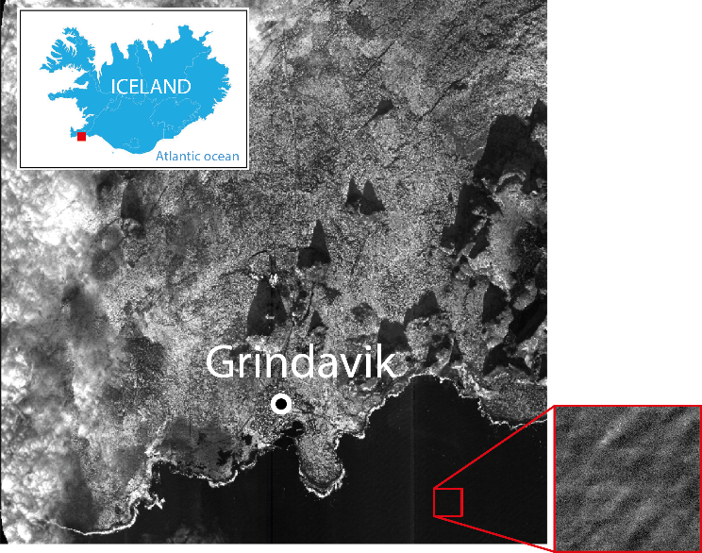

Figure 1. On vous propose de mettre au moins une image

.

2. section 2 (you can have sections in the ABSTRACT)

Hitherto we have explained the phenomena of the heavens and of our sea by the power of gravity, but have not yet assigned the cause of this power. This force arises from some cause that penetrates to the very centers of the sun and planets, without suffering the least diminution of its force; that operates, not according to the quantity of the surfaces of the particles upon which it acts (as mechanical causes used to do), but according to the quantity of the solid matter which they contain, and propagates its virtue on all sides to immense distances, decreasing always in the duplicate proportion of the distances.
And now we might add something concerning a certain most subtle spirit which pervades and lies hidden in all gross bodies; by the force and action of which spirit the particles of bodies attract one another at near distances, and cohere if contiguous; and electric bodies operate to greater distances, as well repelling as attracting the neighboring corpuscles; and light is emitted, reflected, refracted, inflected, and heats bodies; and all sensation is excited, and the members of animal bodies move at the command of the will, namely, by the vibrations of this spirit, mutually propagated along the solid filaments of the nerves, from the outward organs of sense to the brain, and from the brain into the muscles. But these are things that cannot be explained in a few words, nor are we furnished with that sufficiency of experiments which is required to an accurate determination and demonstration of the laws by which this electric and elastic spirit operates.

Index Terms— InSAR, space, Pléiades, CIEST²

3. acknowledgements

Exemple : Pléiades images are distributed by Airbus DS. The bathymetric metadata and Digital Terrain Model data products have been derived from the EMODnet Bathymetry portal - http://www.emodnet-bathymetry.eu.

4. References

[1] Newton, Isaac, 1642-1727. Newton's Principia : the Mathematical Principles of Natural Philosophy. New-York : Daniel Adee, 1846.

[3] W. W. Williams, “The determination of gradients on enemy-held beaches”, The Geographical Journal, 109(1/3), 76–90, 1947.

[4] S. Leprince, S. Barbot, F. Ayoub, and J. -P. Avouac, “Automatic and precise orthorectification coregistration, and subpixel correlation of satellite images: Application to ground deformation measurements”, IEEE Transactions on Geoscience and Remote Sensing, 45, 1529–1558, 2007.

[5] R. Abileah, “Mapping shallow water depth from satellite”, In Proceedings of the ASPRS Annual Conference, San Carlos, CA, USA,1–5 May 2006; pp. 1–7.

